## **Connections to Record the Value for Gain and Plot the Radiation Pattern for Horn Antenna**

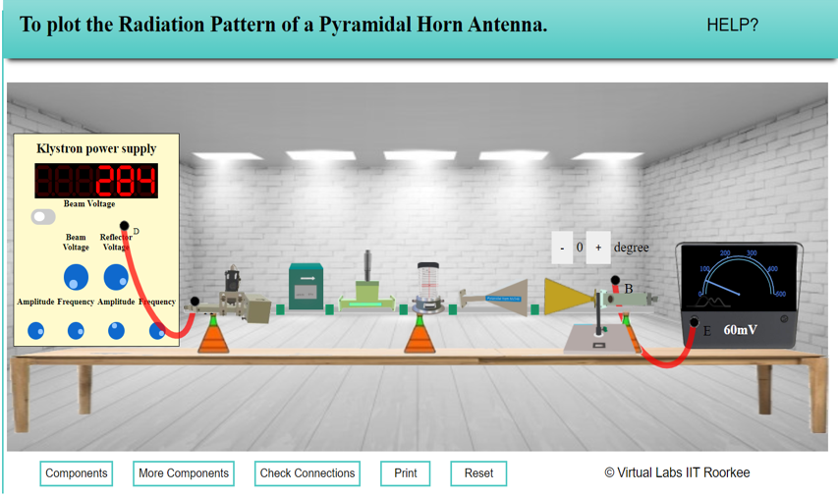

**Readings for Radiation Pattern of Horn Antenna**

# INPUT VOLTAGE VT = 330mv

|  |  |  |  |  |
| --- | --- | --- | --- | --- |
| Angle (degree s) | VR (mv) | | Gain (dB) = 20 log (VR/VT) | |
| Clock wise | Anticlock wise | Clock wise | Anticlock wise |
| 0 | 61 | 60 | -14.66 | -14.81 |
| 5 |  |  |  |  |
| 10 | 56 | 55 | -15.41 | -15.56 |
| 15 |  |  |  |  |
| 20 | 41 | 40 | -18.11 | -18.33 |
| 25 |  |  |  |  |
| 30 | 21 | 20 | -23.93 | -24.35 |
| 35 |  |  |  |  |
| 40 | 16 | 15 | -26.29 | -26.85 |
| 45 |  |  |  |  |
| 50 | 26 | 25 | -22.07 | -22.41 |
| 55 |  |  |  |  |
| 60 | 41 | 40 | -18.11 | -18.33 |
| 65 |  |  |  |  |
| 70 | 61 | 60 | -14.66 | -14.81 |
| 75 |  |  |  |  |
| 80 | 21 | 20 | -23.93 | -24.35 |
| 85 |  |  |  |  |
| 90 | 11 | 10 | -29.54 | -30.37 |

